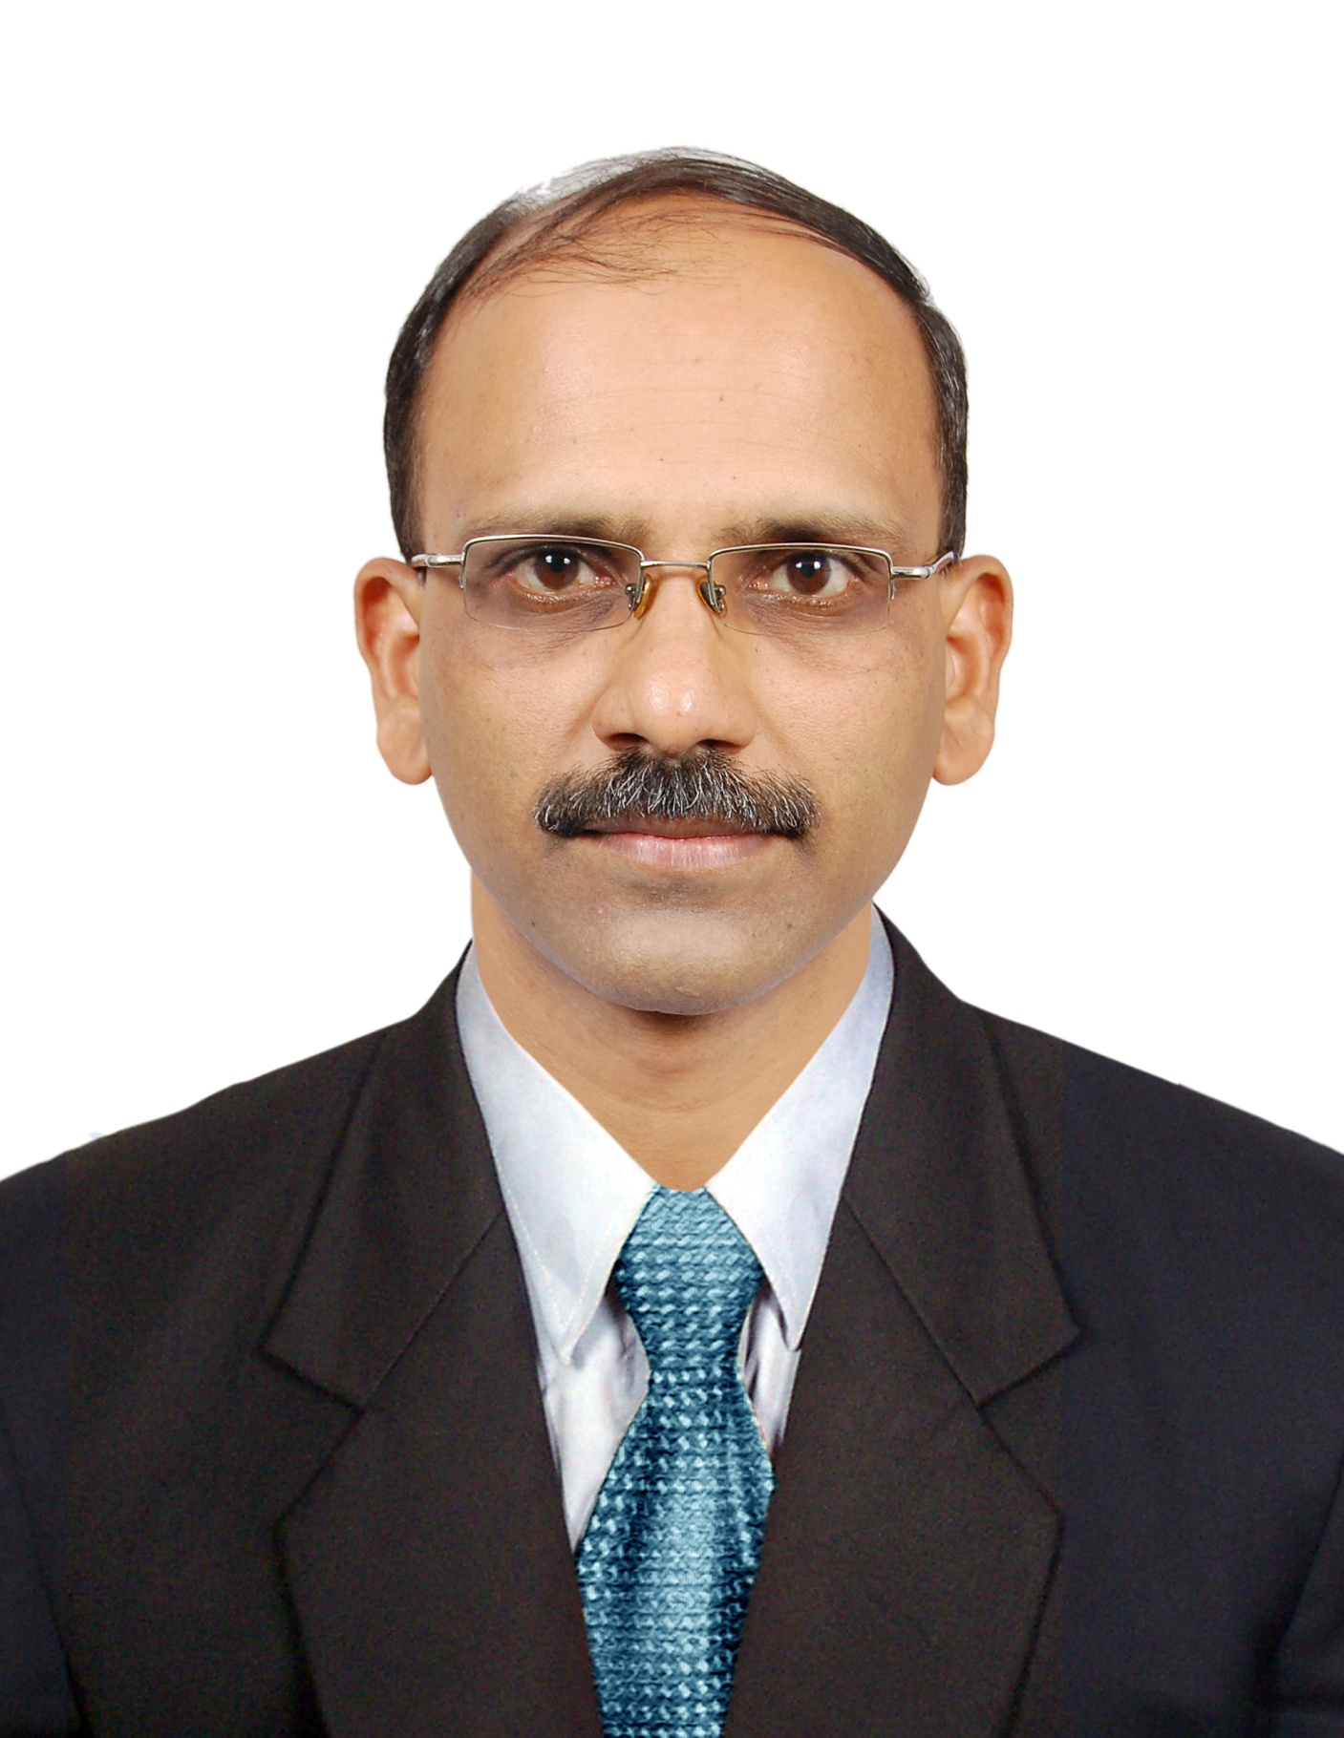 Dr.Ramakrishna B.M
Associate Professor
Dept of Economics, University College
Mangalore-575001
Karnataka, India.
919448427705
rama_bmr@yahoo.co.in

EDUCATIONAL QUALIFICATION : M.A., M.Ed., Ph.D.

Ph. D. awarded on the topic ‘Impact of Privatization on Labour with
Special Reference to Karnataka’
ADDITIONAL QUALIFICATION
- Diploma in Computer Applications
- Diploma in Gandhian Studies

TOTAL TEACHING EXPERIENCE : 23 YEARS

SPECIALIZATION : Labour Economics and Environmental Economics
PUBLICATIONS
  - Research Paper on Impact of Privatisation on Labour with Special Reference to Karnataka published in Finance India (The Quarterly Journal of Finance), Indian Institute of Finance, Delhi, March 2009, Volume XXXIII No.1, ISSN 0970-3772.
  - Research paper on Environmental Problems and Sustainable Development with Special Reference to India published in the Journal of Global Economy, vol.6, No.2 March-April-2010. ISSN O975-3931.
  - 2007-08 Ee Salina Rajya Ayavyaya Pathra- Ondu Avalokana an article published in Yojana,volume 22, No. 9 April 2007, ISSN O971-8737.
  - Research paper on Rural-Urban Disparity in Karnataka:A Perspective published in the edited vol. on Demography Transition in India: Diverse Perspectives by Dr. Ravindra Kumar and others, October,2012, ISBN: 978-81-9242393-2-7
  - Research paper on Parallel Economy in India: Issues and Policy Options published in the Conference volume, by Canara College, Mangalore, Karnataka . January 2014, ISBN: 978-81-927561-4-1.
  - Research paper on Consumer Awareness and Attitude towards Green Products – A Case study in Mangalore City published in the Conference volume, by Canara College, Mangalore, Karnataka . August 2014, ISBN: 978-81-927561-2-7.
  - Paper on Privatisation and Insurance Sector in India: Emerging Issues and Policy Options published in the Journal of Development and Social Change, vol. 3 No. 1& 2, Jan – March, 2006.
  - Research paper on Labour Laws and Women Empowerment in India published in the Journal of Development and Social Change, vol. 3, No. 3 & 4 April – June, 2006.
  - Bharathadallina Karmika Kanunugalu mathu Mahila Sabalikarana, a research article published in the Edited Book on Mahile Mathu Abhivridhi by Dr. Jayasheela, 2007.
  - Paper on Privatization and Social Security Measures in India: Issues and Strategies in the edited book on Social Security, Insurance and Pension Sector Reforms, by Prof. O. D. Heggade, Arun Publishing House, Mysore, 2006.
SEMINARS AND CONFERENCES
INTERNATIONAL: PAPER PRESENTED:
- Presented Paper in the International Conference on Environmental Problems and Sustainable Development with Special Reference to India, held at Dept of Geography, Hongkong Baptist University, Hong Kong from 1-3 June, 2006.
- Paper Presented in the International conference of Indian Society for Ecological Economics (ISEE) on ‘The Problems and Prospects of Mangroves in Coastal Karnataka’ held at the India Habitat Centre New Delhi, from 15-18 December 2006.
- Paper presented in the International Conference on Rural-Urban Disparity in Karnataka:A Perspective, held at Dept of Economics, Tumkur University, Tumkur On 12-13, October, 2012.

- Presented Paper in the International Conference on Environmental Problems and Sustainable Development with Special Reference to India, held at The National University of Malaysia, Malaysia on 27th March 2013.
- Presented Paper in the International Conference on Impact of Globlisation on Indian Poverty, held at Milagres College, Kundapur on 6th -7th March 2014
NATIONAL: PAPER PRESENTED:
Paper Presented in Two Day National Seminar on Privatization of Insurance Sector in India : Emerging Issues and Policy Options held at Sir M. Visvesvaraya Post-Graduate Center, Mandya, 17th and 18th February – 2005.
- Paper Presented in One day National Seminar on ‘The Private Players in Indian Insurance Industry’ held at Osmania University, Hyderabad on 8th August 2008.
- Presented a Paper entitled Labour Laws and Women Empowerment in India in the National Seminar on ‘India- Sixty Years in Nation’s Life’ held on 3rd and 4th April 2009, at Besant Evening College, Mangalore
- Presented a paper entitled Customer Perspectives towards Mobile Banking Services- A Case study with reference to Costal Karnataka in the National Conference held during 17th -19th April 2012 at University College, Mangalore, Karnataka.
- Presented a paper entitled Parallel Economy in India: Issues and Policy Options in the National Conference held during 3rd - 4th January 2014 at Canara College, Mangalore, Karnataka.
- Presented a paper entitled Consumer Awareness and Attitude towards Green Products – A Case study in Mangalore City in the National Conference held on 23-24 January 2014 at Canara College, Mangalore, Karnataka.
- Presented a paper entitled Social Security for Woman Workers in the Unorganised Sector in the National Conference held on 22-23 April 2014 at University College, Mangalore, Karnataka.
- Presented a paper entitled Woman Representation in Civil Services in India in the National Conference held on 12-13 September 2014 at University College, Mangalore, Karnataka.

Project Completed:
Minor research project on the topic Rural- Urban disparities in Karnataka: A Case Study of D.K District

